Week 1

1. Methodologies
   1. Code-a-bit-test-a-bit (CABTAB)
      1. Hardly a methodology, although widely used in programming
      2. Suitable for small systems of limited scope
   2. Waterfall
      1. Suit to projects of limited uncertainty and risks
      2. Drawbacks
         1. Each step has documentation and user cannot have a full view
         2. Not flexible. All base on documentation
   3. Rapid prototyping
      1. The building of prototype clarifies requirements and system scope. They should never become the final system.
      2. Time is crucial for the prototype.
   4. Iterative and incremental
      1. Built through a series of time-boxed development cycles-iterations-leading to the overall system functionality-increments.
      2. Expedient model for building systems with initial ambiguity of scope and changing requirements.
   5. Agile methods
      1. Individuals and interactions over processes and tools
      2. Working software over comprehensive documentation
      3. Customer collaboration over contract negotiation
      4. Responding to change over following a plan
2. Software development life cycle (SDLC)
   1. Requirements

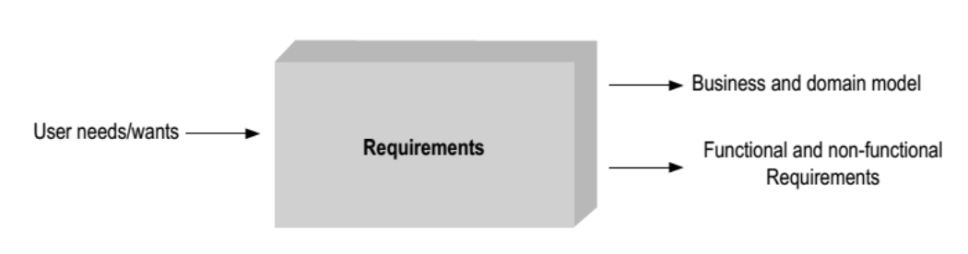

* 1. Analysis

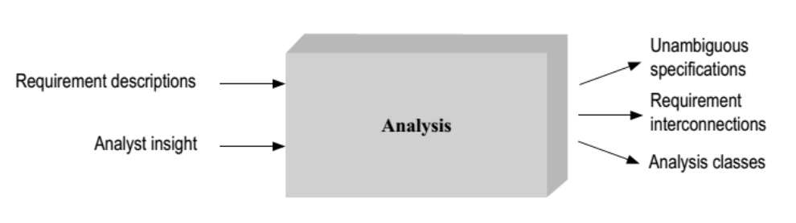

* 1. Design

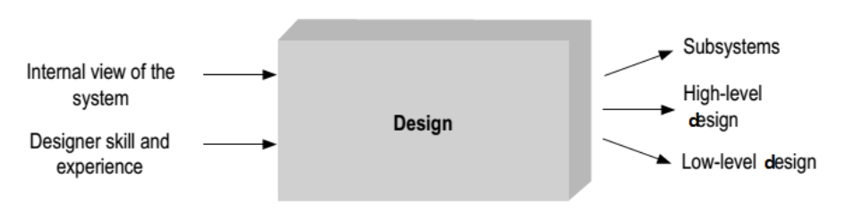

* 1. Implementation

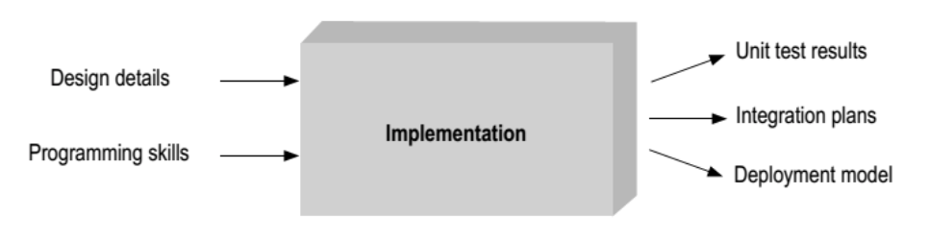

* 1. testing

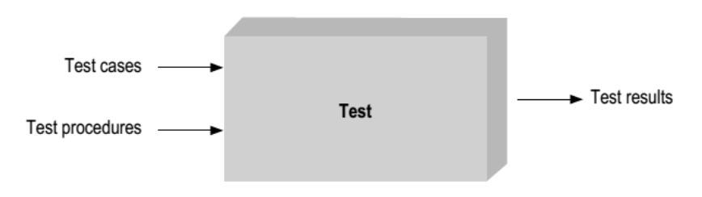

1. The software equation

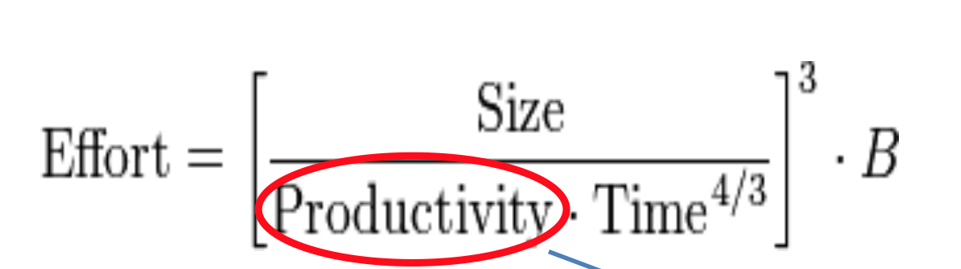

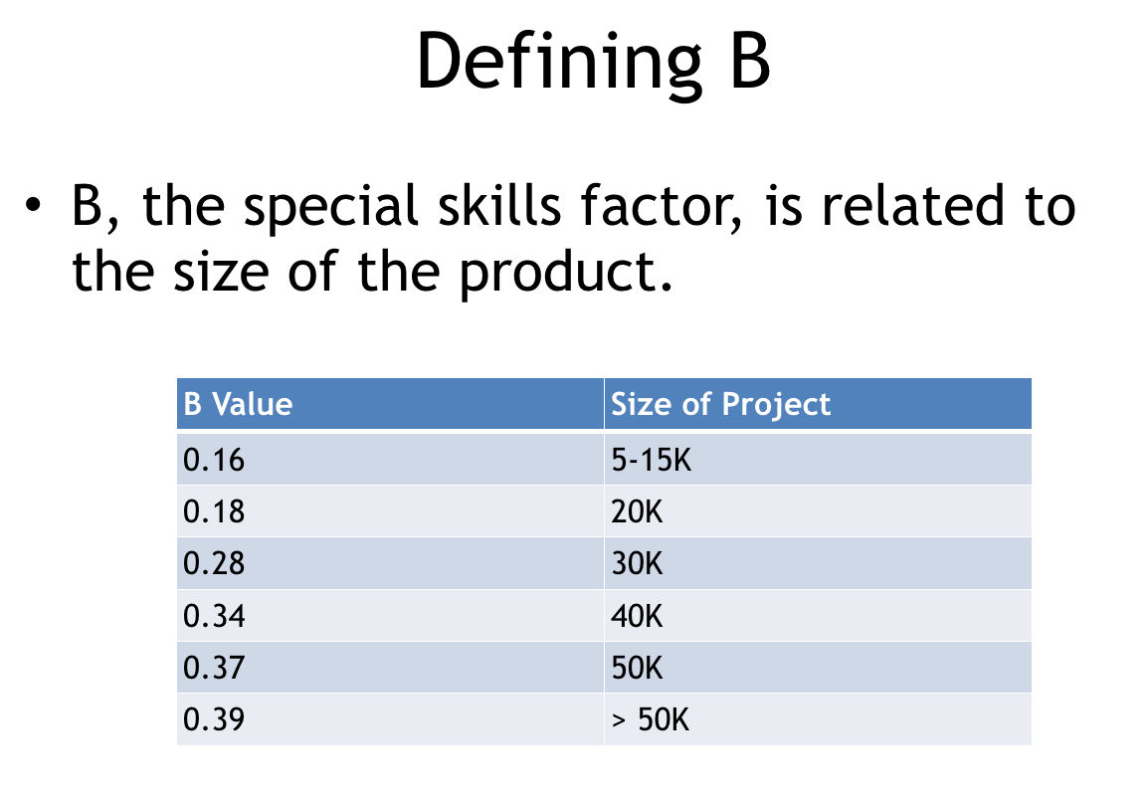 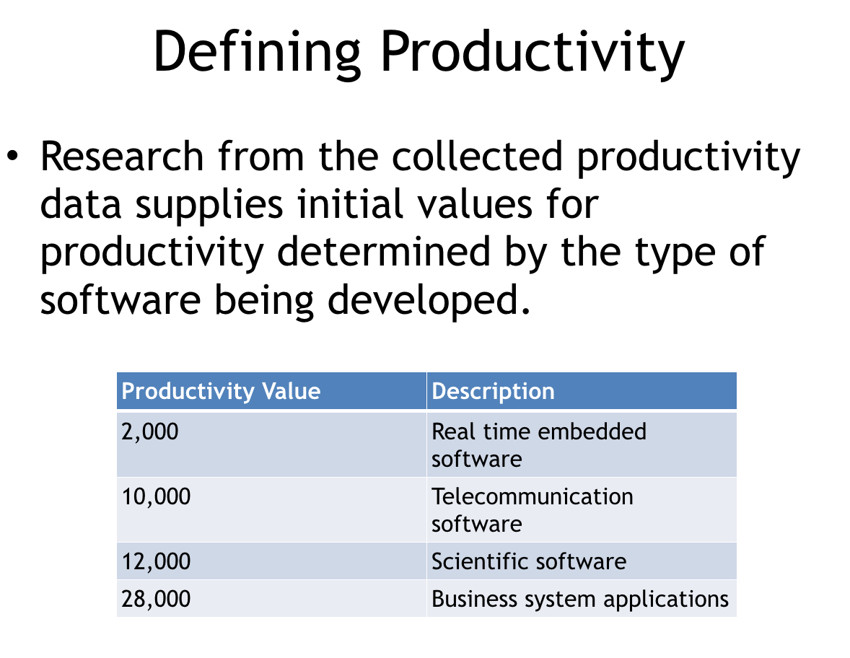

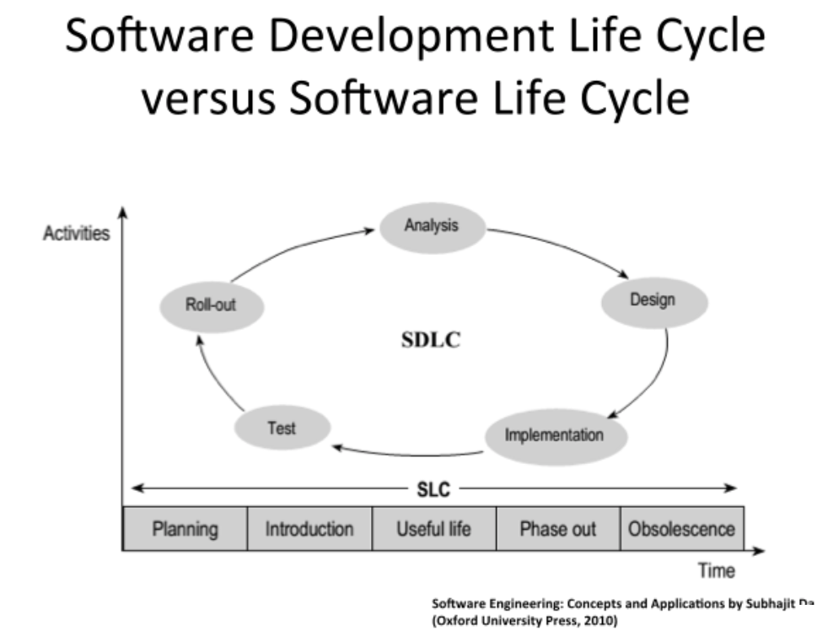

Week 2 & Week 3

1. The rational model (drawbacks: 1. Uncertainty to make decision. 2. Time consuming)
   1. Until (“good enough”) or (time runs out) {
   2. Do another design (to improve utility function)
   3. Until design is complete
   4. Backtrack up design tree
   5. Explore a path not searched before While design remains feasible,
   6. make another design decision
   7. EndWhile
   8. EndUntil
   9. EndDo
   10. Take best design
   11. EndUntil
2. Addressing complexity in design
   1. Decomposition

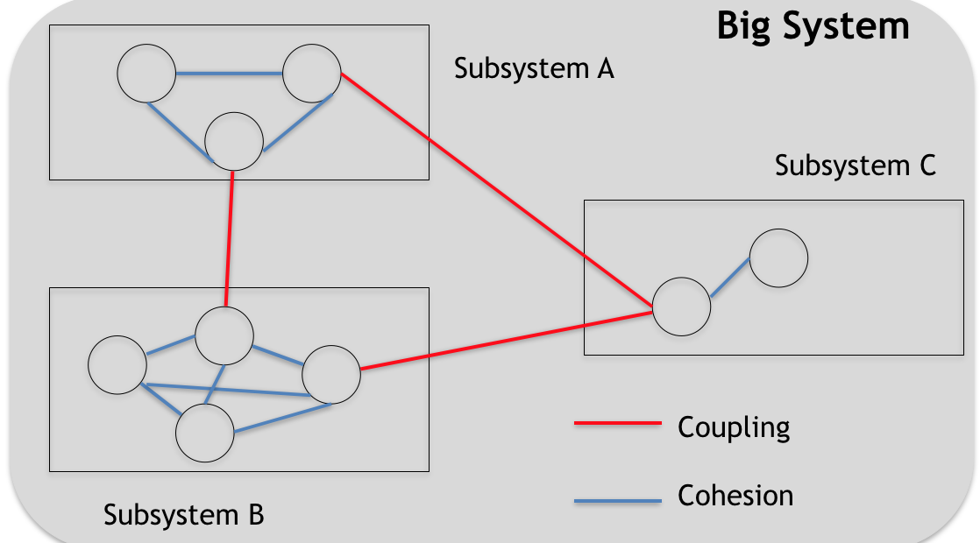

* 1. Abstraction
     1. Abstract away the low-level implementation detail

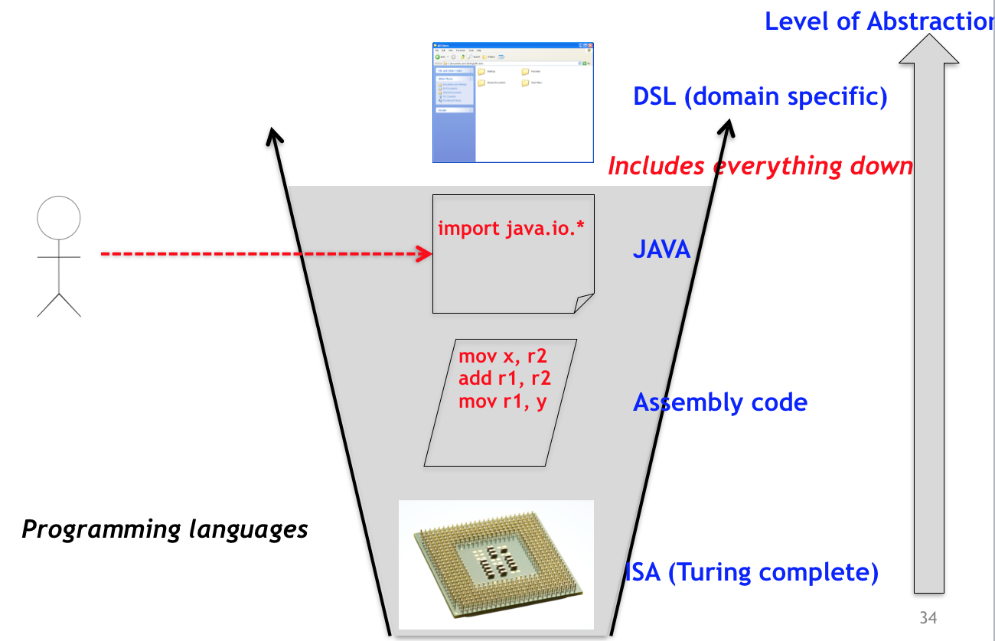

* 1. Hierarchy
     1. Find common characteristic it shares with other things we know, or if it is part of something we have seen earlier

1. Modeling languages
   1. Mainly for documentation and communication
   2. UML is unified modelling language with 14 diagram types
   3. UML is extensible and flexible
2. Flow of events
   1. Basic flow of events
   2. Alternative flow of events
   3. Exception flow of events
3. UML diagrams
   1. Use case diagrams
      1. Show a set of use cases and actors and their relationships
      2. Represent system functionality, the requirements from of the system from the user’s respective
      3. Include, extend, precedes (before targeted use case)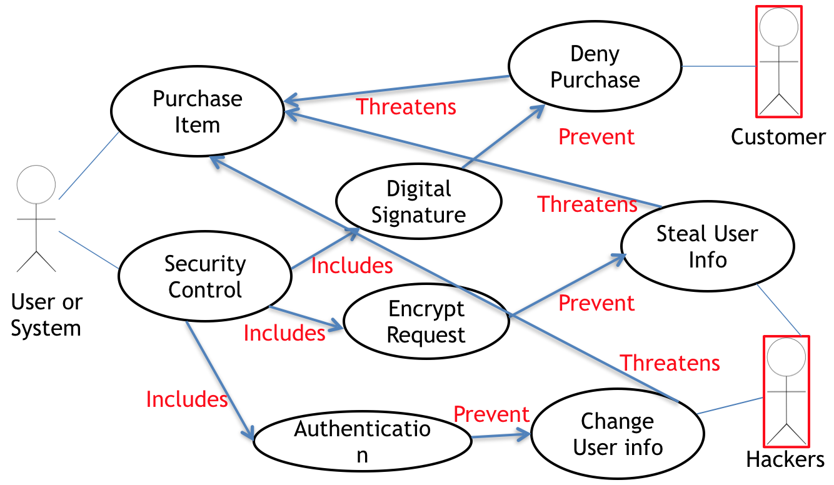
   2. Sequence diagrams
      1. Synchronous (solid arrowhead)
      2. Asynchronous (stick arrowhead)
      3. Alternatives, loop, timeout
      4. parallel

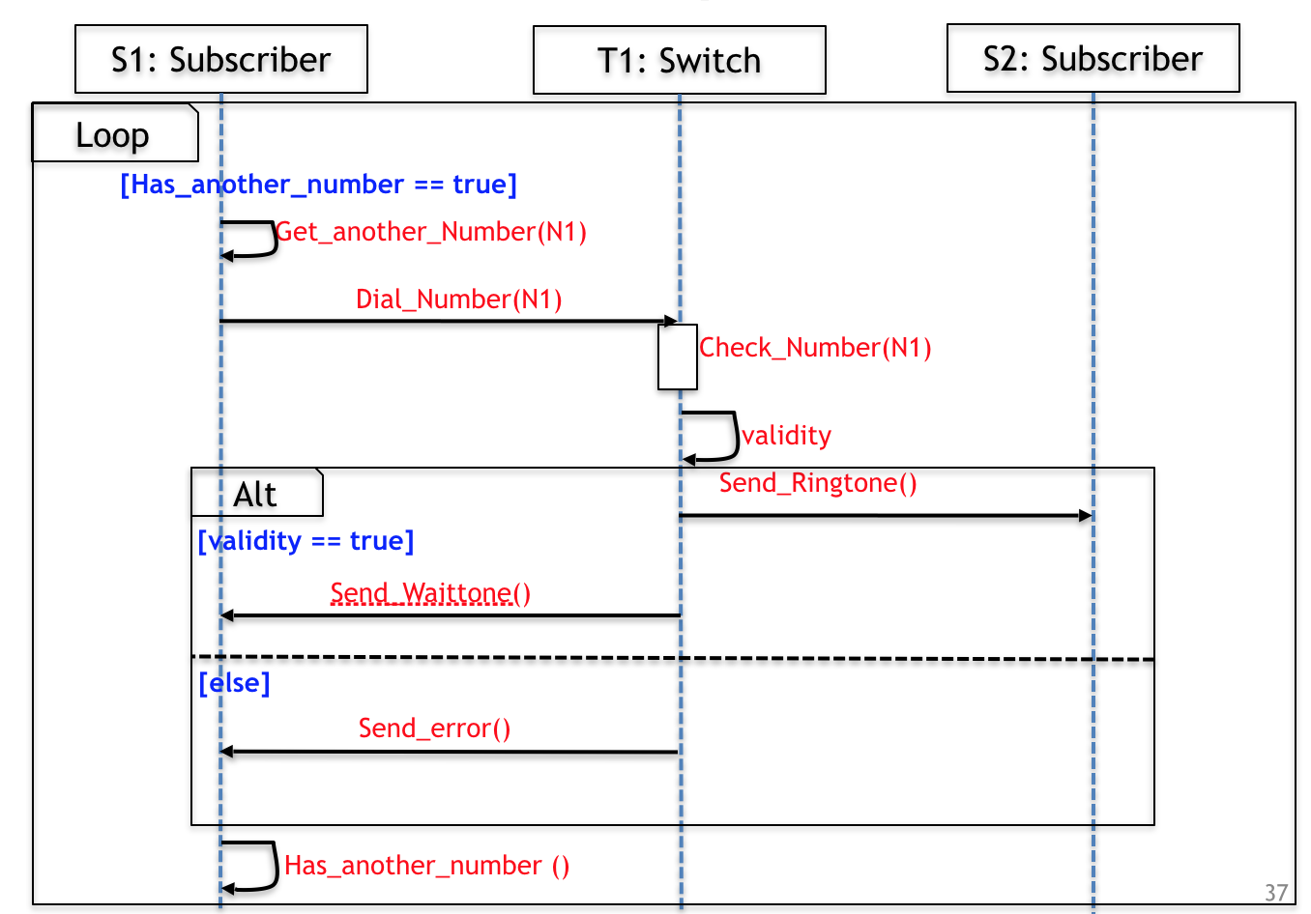

* 1. Class diagrams
     1. Used to model object-oriented systems
     2. Inheritance (solid line), interfaces (dotted line)
     3. Associations: bi-directional, uni-directional
  2. State diagrams

Week 4 Design patterns

1. Factory pattern
   1. Without exposing the instantiation logic to the client
   2. Refer to the newly created object through a common interface
2. Observer design pattern
   1. Used when need many other objects to receive an update when another object change.
   2. The subject doesn’t need to know anything about the observers
3. Decorator pattern
   1. A flexible alternative to subclassing for extending functionality should be provided.
4. Strategy design pattern
   1. Define a class that will have one behavior that is similar to other behaviors in a list
   2. When you need to use one of several behaviors dynamically

Week 5 & Week 6 Testing

1. Junit
   1. Junit test fixtures
      1. Objects used in test fixtures should be declared as instance variables
      2. @Before, @After
   2. Parameterized Tests
      1. Test a function with similar values
   3. Each test is embedded into one test method
   4. A test class contains one or more test methods
2. Black box testing
   1. Test based on specification
      1. High-level specification (UI, Web server, Internet server)
      2. Low-level specification (documentation in the code)
   2. Better at finding whether code meets the specification
   3. Consideration
      1. Generate according to requirements/problem statement
      2. Test cases need to be traceable to a requirement
      3. Repeatable test case
      4. Run the simplest test case first to make sure basic functionality works
   4. Equivalence class partitioning
      1. Divide input conditions into groups(class)
   5. Boundary value analysis (boundary values of a partition)
      1. E.g. max length email in valid partition
      2. E.g. only one extra @ in invalid partition
   6. Dirty/Failure test cases
      1. Divide by zero, wrong input type, illogical path, mandatory fields not entered, abort abruptly, unplug input device
3. White box testing
   1. Test based on code, cover implemented behaviors
   2. Better at finding crashes
   3. Coverage (method, statement (cannot test false condition), branch, path, condition (each parameter in a statement need to be covered with true false), loop)
   4. Control flow graph
4. Fault-based testing (from common errors)
5. Mock testing
6. Fuzzing testing
   1. Mutation (flipping a bit, trimming, swapping character, inserting characters)
7. Safe coding practices
   1. Check all array bounds
   2. Apply bounds on program inputs
   3. Check all return values of a function
   4. Do not trust third-party inputs
8. Grammar
   1. (23 \*56) /(1.2 +2)

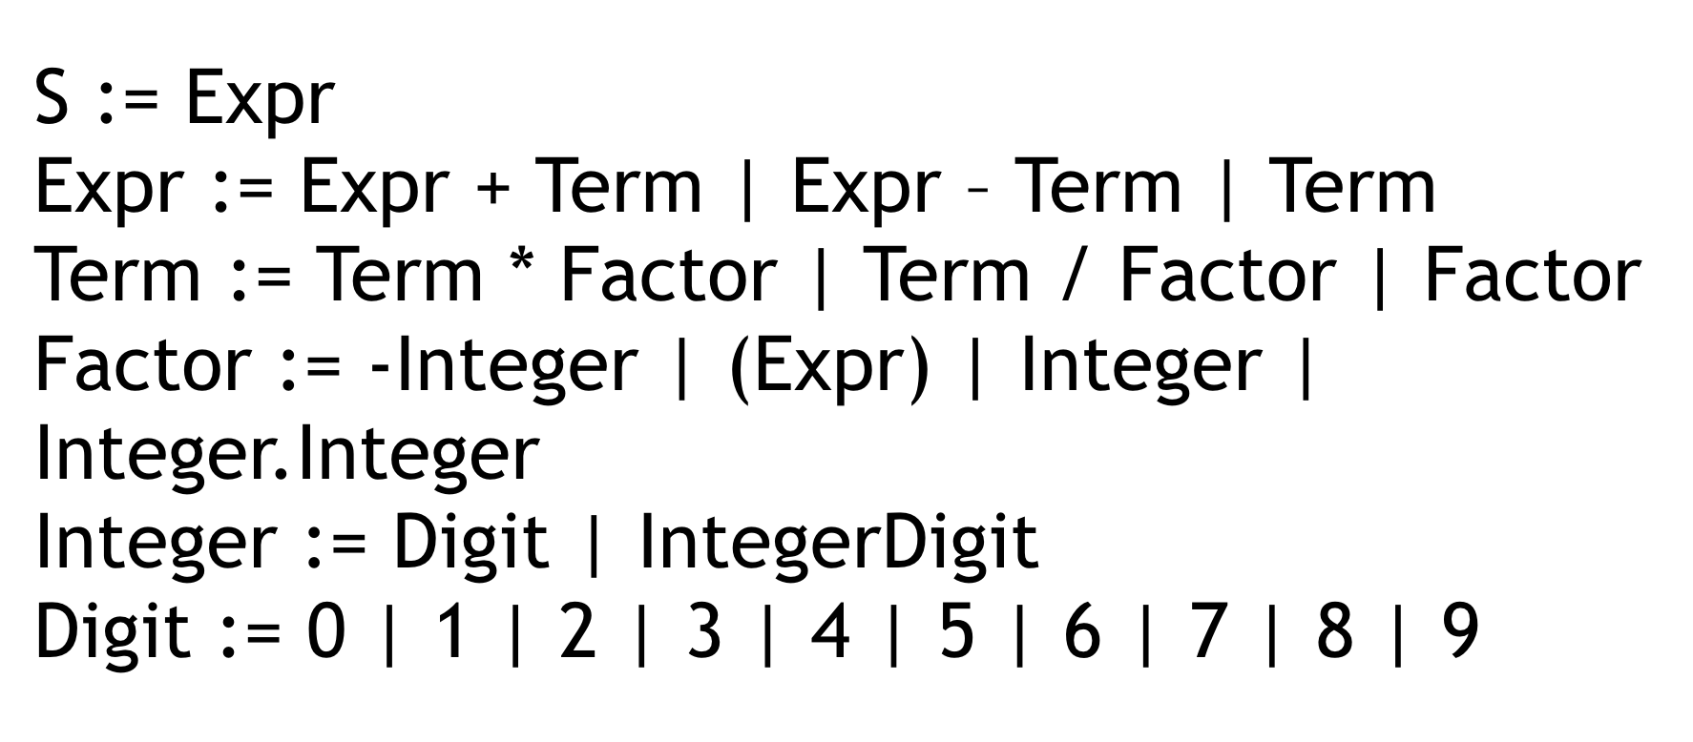

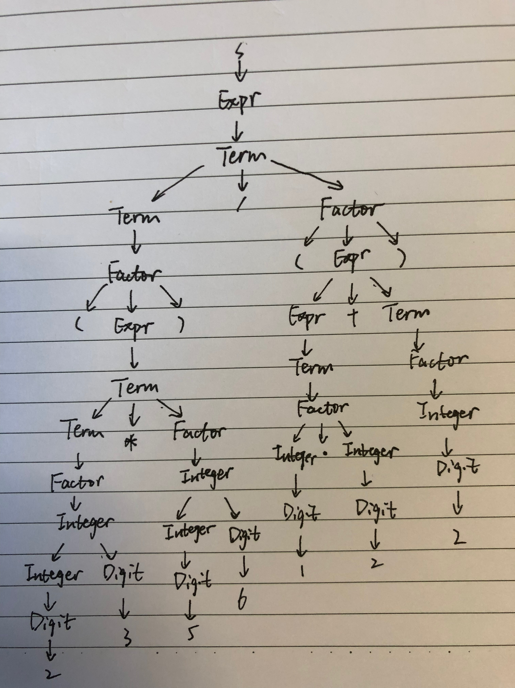

Week 8 Code smells and refactoring

1. Comments
   1. Used to document
      1. APIs
      2. Choices of data structure and algorithms
   2. Don’t over comment
2. Comments that reflect potential changes to be made in a different method are indication of code smells
3. Repeated code
4. Long method (should be single and clear objective)
5. BlackHole classes
   1. Classes start small
   2. Adding more responsibility to a class attracts further responsibilities
6. Data class
   1. Too small of a class without much responsibility
7. Data clumps
   1. Opposite to data classes
   2. It’s better to create a class if a set of parameters are used repeatedly
8. Long parameters
9. Shotgun surgery
   1. Adding a simple feature may need to change all over the code
10. Feature envy
    1. If class A is talking to class B unusually frequent, they better be together
11. Long message chains
    1. Should avoid calling a long sequence of messages without checks
    2. E.g. A.B().C().D().E()
12. Speculative generality
    1. Should avoid over engineering based on unlikely generalization
13. Refused bequest
    1. Bad inheritance

Week 9 Concurrency

1. Requirement, analysis
   1. Pre-condition, post-condition, non-functional requirement
   2. If precondition is satisfied, the method guarantees postcondition
2. Sequential program
   1. The textual order of statements specifies order of execution
   2. Successive statements must be executed without any overlap in time with one another
3. Race condition
   1. Two or more operations are not operated in sequential
   2. Can be solved by synchronization
4. Visibility
   1. Volatile variables
      1. An update to a volatile variable is propagated predictably to other threads. It updates the value to memory immediately.
5. Execution ordering
   1. Similar to race condition. Solved by synchronization
6. Deadlock
   1. Two or more threads are both waiting for the others to complete, forever.
7. Other liveness hazards
   1. Deadlock is most widely encountered liveness hazard
   2. Starvation occurs when a thread is denied access to resources it needs in order to make progress (caused by thread priority or executing infinite loops with a lock held)
   3. Poor responsiveness
   4. Livelock. (keep trying an operation that will always fail)
8. Requirements of multi-thread programs
   1. No race condition, no visibility issue, no execution ordering problem, no deadlocks, efficiency
   2. Race condition can be benign
9. Thread safety
   1. Specification
      1. Class invariants, precondition, postcondition, assertions
   2. No sharing
   3. Constants
   4. AtomicXXX
   5. Intrinsic locks
   6. Reentrancy
      1. Methods in father classes or self-classes can be reentered.
      2. If other thread is holding the lock, cannot be reentered.
10. Achieving thread safety
    1. Update related state variables in a single atomic operation
    2. All accesses to the variable must be performed with the same lock held
    3. Every shared, mutable variable should be guarded by one lock
    4. For every invariant that involves more than one variable, all the variables involved in that invariant must be guarded by the same lock
11. Synchronization cannot fix the execution ordering issue

Week 10 Concurrency: Design and Implementation

1. From scratch
   1. Identify the variables that form the object’s state
      1. State includes all of its mutable variables
      2. Use ‘final’ as long as you can
   2. Identify the requirements
   3. Establish a policy for managing concurrent access to the objects state
   4. Implement the policy
2. By extending the class
   1. There is a thread-safe class supporting almost all the operations you want
   2. You know the locking policy of the class to follow
   3. Don’t have the source code
   4. More fragile than modifying the class directly, because the implementation of the locking policy
3. Through client-site locking
   1. Add methods to exist class
   2. Don’t have the source code or enough access to the internal state so that we can extend the class.
   3. You know the client’s locking policy
   4. More fragile than extending the class because it distributes the locking policy for a class into classes that are totally unrelated
4. Through composition
   1. Less fragile
   2. It doesn’t care whether the original class is thread-safe or not
   3. It adds performance penalty due to the extra layer of synchronization
5. Documenting
   1. One of the most powerful tools for managing thread safety.
6. Encapsulating data
   1. Identify the intended scope of objects
   2. Instance confinement is one of the easiest ways to build thread-safe classes
   3. Make sure the objects don’t escape their scope
7. Remedy for deadlock
   1. All threads acquire the locks they need in a fixed global order
   2. Strive to use open calls(method with no locks held) throughout your program
   3. Use the timed tryLock feature of the explicit lock class instead on intrinsic locking (tryLock can do something else it is not able to acquire the lock)
8. Concurrency-related library
   1. Synchronized collections
      1. Hashtable
      2. Collections.synchronizedXXX
      3. If modification count changes during compiling, throw exception
   2. Concurrent collections
   3. Synchronizers

Week 11

1. Synchronizers
   1. Semaphore
      1. Maintain a set of permits.
   2. Cyclic Barrier
      1. A synchronization aid that allows a set of threads to all wait for each other to reach a common barrier point.
   3. CountDownLatch
      1. A synchronization aid that allows one or more threads to wait until a set of operations being performed in other threads completes.
   4. Phaser
      1. Reusable synchronization barrier, similar in functionality to CyclicBarrier and CountDownLatch but supporting more flexible usage

